Exploratory Data Analysis of E-Commerce Sales Data

Overview

This project was completed during the Decode Labs Data Analytics Internship Program and focused on the exploration and analysis of an e-commerce sales dataset using Power BI. The objective was to uncover meaningful trends, customer purchasing patterns, product performance insights, and revenue distributions that could support business decision-making.

By analyzing customer transactions, sales performance, payment methods, and order statuses, valuable insights were generated to better understand business operations and customer behavior.

Objectives

The main objectives of this analysis were to:

Identify products that contribute the most to overall revenue.

Determine customers with the highest revenue contributions.

Analyze customer payment method preferences.

Examine the distribution of different order statuses.

Evaluate sales revenue trends over time.

Generate actionable business recommendations based on analytical findings.

Dataset Description

The dataset, provided by DecodeLabs, contained various transactional records, including:

Order ID

Date

CustomerID

Product

Quantity

Unit Price

Shipping Address

Payment Method

Order Status

Tracking Number

Items In Cart

Coupon Code

Referral Source

Total Price

Data Preparation

Before conducting the analysis, the dataset underwent a cleaning process to improve its quality and reliability. This process involved identifying and handling missing values, checking for duplicate records, and ensuring that all data fields were properly formatted for analysis.

Analysis Questions

The following business questions guided the exploratory analysis:

Which products generate the highest sales revenue?

Which customers contribute the most to revenue generation?

What payment methods are most commonly used by customers?

What proportion of orders are delivered, shipped, pending, cancelled, or returned?

How does revenue fluctuate over time?

Analysis Process

The exploratory analysis was performed using Power BI. Various visualizations, DAX measures, and analytical techniques were utilized to identify trends, patterns, and distributions within the dataset.

Several key performance indicators (KPIs) were calculated to provide an overview of business performance:

Total Orders: 1,200

Total Revenue: ₦1,264,761.96

Average Order Value: ₦1,053.97

Median Order Value: ₦823.62

These metrics provided a high-level summary of transaction activity and overall sales performance.

Visualization
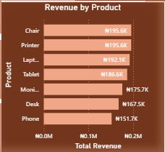
This analysis identified the products contributing to high sales revenue within the dataset.

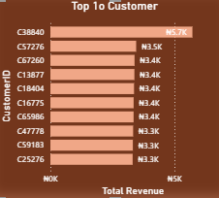

This analysis identified the customers that generate high sales revenue.

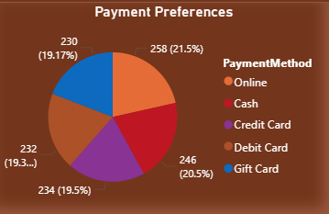

This analysis evaluated the payment method that are used by customers.

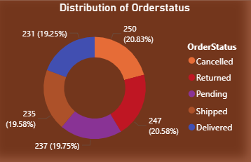

This analysis examined the percentage of orders that are cancelled, delivered, pending, returned or shipped.

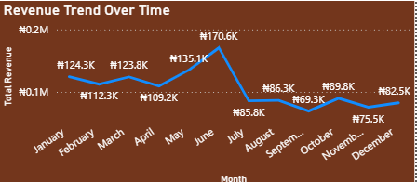

This analysis examined monthly revenue patterns to see changes over time

Dashboard Overview
To present the results in an interactive format, a Power BI dashboard was developed. The dashboard combined KPI cards, charts, and slicers into a single reporting interface, allowing users to explore revenue trends, product performance, customer behavior, payment preferences, and order status distributions dynamically.
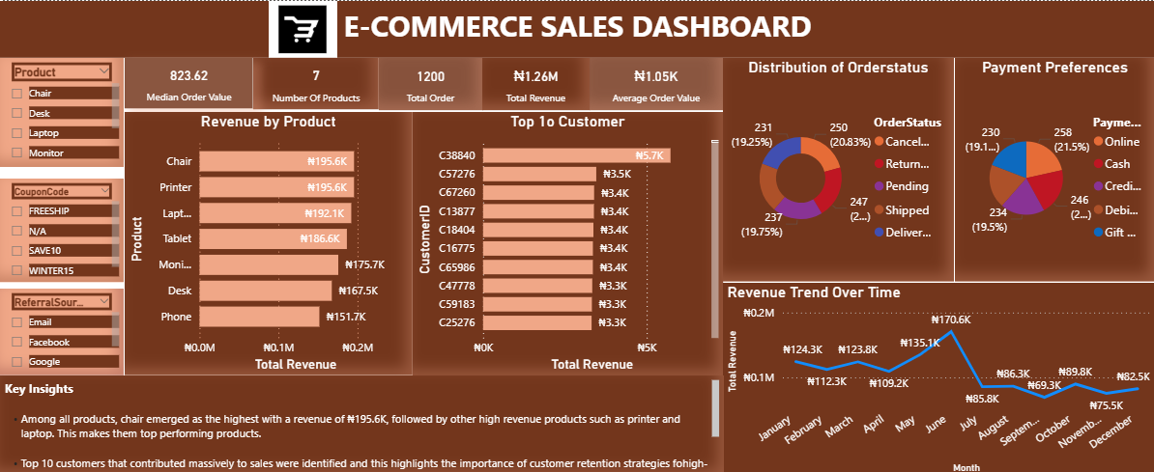

Key Findings
The analysis revealed several significant insights:
- Chairs generated the highest revenue among all products, contributing approximately ₦195.6K in sales. Printers and laptops also recorded strong revenue performance, making them key revenue-driving products.
- The top ten revenue-generating customers were identified, highlighting a group of high-value customers who play an important role in overall business performance.
- Online payment emerged as the most frequently used payment method, followed by cash, credit card, debit card, and gift card transactions.
- Approximately 41.4% of all orders were either cancelled or returned, representing a substantial operational and revenue challenge.
- Revenue performance peaked between May and June, reaching approximately ₦170.6K before experiencing a steady decline during the second half of the year.

Recommendations
Based on the findings, the following recommendations are proposed:
- Products with strong revenue performance, particularly chairs, printers, and laptops, should receive increased marketing support and inventory allocation to maximize profitability. Lower-performing products such as desks and phones should be reviewed to determine factors affecting their sales performance.
- High-value customers should be targeted with personalized promotions, loyalty programs, and engagement strategies to encourage repeat purchases and strengthen customer retention.
- Since online and cash payments account for the majority of transactions, efforts should be made to maintain secure, reliable, and efficient payment systems to enhance customer experience.
- The high percentage of cancelled and returned orders should be investigated to identify underlying causes, such as delivery delays, product quality concerns, inaccurate product descriptions, or customer service issues.
- The factors responsible for the revenue increase observed between May and June should be examined and, where possible, replicated during lower-performing periods to improve overall sales performance.

Conclusion
The exploratory analysis successfully uncovered important trends and patterns within the e-commerce sales dataset. Revenue performance varied throughout the year, with the strongest results recorded between May and June. Chairs were identified as the leading revenue-generating product, while online payment remained the preferred transaction method among customers.
The analysis also highlighted a significant proportion of cancelled and returned orders, indicating opportunities for operational improvement. Additionally, the identification of top-performing customers provides valuable insights for customer retention and revenue growth initiatives.
Overall, the project demonstrates how data-driven analysis can be used to support strategic decision-making and improve business performance.

